Project 1: Slopes and Intercepts

Part 1: Notice and Wonder Graph Features
Examine the following graph. Take a minute to think of at least one thing you notice and one thing you wonder.
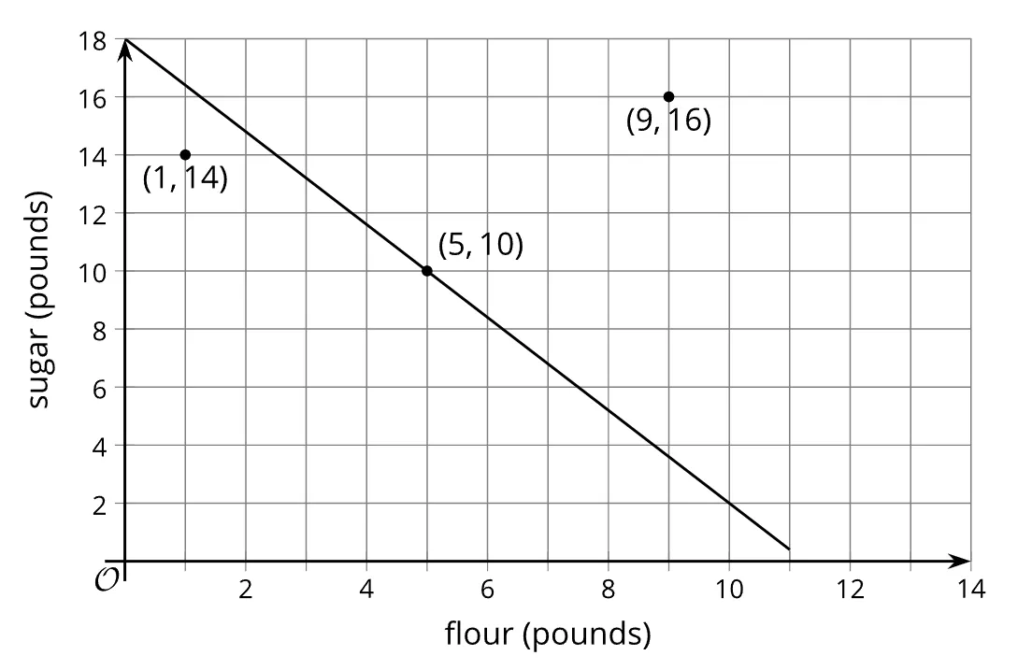
- What do you notice? What do you wonder?

Part 2: Matching
Now you will be playing a matching game, complete the steps listed below, answering questions 1-4 as directed.

Round 1: Key Features
Step 1 - Deal out the graph cards face up.
Step 2 - Take turns choosing a graph and discussing it with your partner.
- For each graph you find, tell your partner the $x$-intercept, $y$-intercept, and slope.
- For each graph your partner picks, see if you agree with their thinking. If you agree, write their answers down on the graph for them. If you disagree, discuss your thinking and work to reach an agreement.
Step 3 - Record your answers to question 1.
- For each graph (A, B, C, and D) record the $x$-intercept, $y$-intercept, and the slope.
  - Graph A
  - Graph B
  - Graph C
  - Graph D

Round 2: Equation Matches
Step 1 – Deal out the equation cards face up, leaving the graph cards visible.
Step 2 – Take turns matching each graph with an equation and discussing it with your partner.
- For each match you find, explain to your partner how you know it’ a match.
- For each match that your partner finds, listen carefully to their explanation. If you disagree, discuss your thinking and work to reach an agreement.
Step 3 - Record your answers to question 2.
- For each graph (A, B, C, and D), record which equation(s) match and explain how you and your partner know these are a match.
  - Graph A
  - Graph B
  - Graph C
  - Graph D

Round 3: Scenarios
Step 1 – Write a real-world problem that could be modeled by one of the equations or graphs.
Step 2- Take turns discussing your real-world problem with your partner.
- Choose a point on the graph and explain what it represents in your situation.
- Explain what the slope means in the context of your problem.
Step 3 - Record your answers to questions 3-4.
- Write a real-world problem that could be modeled by one of the equations or graphs.
- Explain what the point and the slope represent in your situation.

